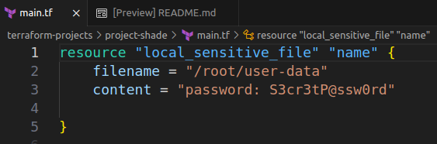
LAB 13: Count & for each

Q-1 A new configuration directory has been created at /root/terraform-projects/project-shade. Inspect it. How many files will be created by this configuration?
A-1 1.

Q-2 Now add a count argument to create 3 instances of this resource.
When ready, run terraform init, plan and apply
A-2 add ,
count = 3 after content argument.
Then apply – so ,only 1 file will be created called user-data.
Bcz, you did not write index number , if you give index number and count = 3 , you can create 3 different files called user-date[0], user-data[1], user-data[2].

Q-3 The resource local_sensitive_file.name is now created as:
A-3 Since we used count, the resources are now created as list.

Q-5 How many files were actually created when apply was run ?
A-4 1

Q-6 We have now created a variables.tf file in the same configuration directory. Update the main.tf file to make use of the list type variable defined for the filename argument.
Use count to loop through all the elements of this list and do not use hard-coded values.
Use the variable called content for the argument called content.
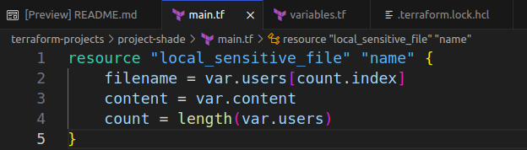
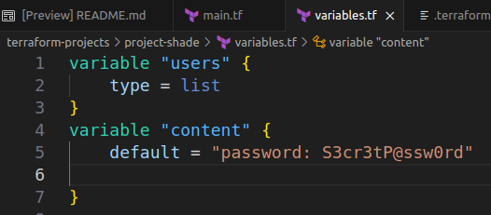

Q-7
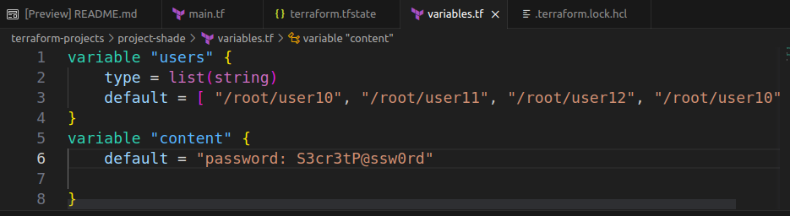
We have reverted back to the old configuration file and cleaned up the resources created so far.
A variable called users now has default values added to it.
What type of variable is it?
A-7 list(string)
Q-8
Can the same elements in this list be used as it is for a set instead?
A-8 No.

Q-9
Let's do the same exercise as before but this time we will make use of the for_each meta argument to create the files in this configuration.
Just like before don't use any hard-coded values.
Use for_each to loop through the list type variable called users.
Use the variable called content as the value of the argument content within main.tf.
When ready, run terraform init, plan and apply.
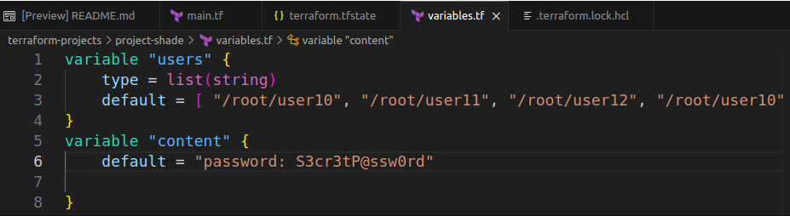
A-9 BEFORE
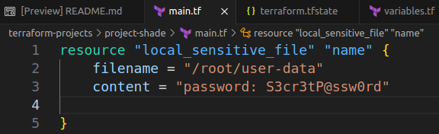

AFTER
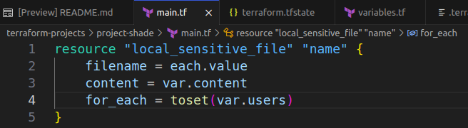

here, we use toset for convert variables into lists.

Q-10
The resource called name is now created as:
A-10 map

Q-11
The resource address with the filename - /root/user11 is now represented as:
A-11 local_sensitive_file.name["/root/user11"]

local_sensitive_file.name["/root/user11"] will be created
+ resource "local_sensitive_file" "name" {
+ content = (sensitive value)
+ content_base64sha256 = (known after apply)
+ content_base64sha512 = (known after apply)
+ content_md5 = (known after apply)
+ content_sha1 = (known after apply)
+ content_sha256 = (known after apply)
+ content_sha512 = (known after apply)
+ directory_permission = "0700"
+ file_permission = "0700"
+ filename = "/root/user11"
+ id = (known after apply)
}

# local_sensitive_file.name["/root/user12"] will be created
+ resource "local_sensitive_file" "name" {
+ content = (sensitive value)
+ content_base64sha256 = (known after apply)
+ content_base64sha512 = (known after apply)
+ content_md5 = (known after apply)
+ content_sha1 = (known after apply)
+ content_sha256 = (known after apply)
+ content_sha512 = (known after apply)
+ directory_permission = "0700"
+ file_permission = "0700"
+ filename = "/root/user12"
+ id = (known after apply)
}

Plan: 3 to add, 0 to change, 3 to destroy.

Do you want to perform these actions?
Terraform will perform the actions described above.
Only 'yes' will be accepted to approve.

Enter a value: yes

local_sensitive_file.name[1]: Destroying... [id=6b32344cb73c40d126d99ce62309878befca64ce]
local_sensitive_file.name[2]: Destroying... [id=6b32344cb73c40d126d99ce62309878befca64ce]
local_sensitive_file.name[0]: Destroying... [id=6b32344cb73c40d126d99ce62309878befca64ce]
local_sensitive_file.name[1]: Destruction complete after 0s
local_sensitive_file.name[2]: Destruction complete after 0s
local_sensitive_file.name[0]: Destruction complete after 0s
local_sensitive_file.name["/root/user11"]: Creating...
local_sensitive_file.name["/root/user10"]: Creating...
local_sensitive_file.name["/root/user12"]: Creating...
local_sensitive_file.name["/root/user11"]: Creation complete after 1s [id=6b32344cb73c40d126d99ce62309878befca64ce]
local_sensitive_file.name["/root/user10"]: Creation complete after 1s [id=6b32344cb73c40d126d99ce62309878befca64ce]
local_sensitive_file.name["/root/user12"]: Creation complete after 1s [id=6b32344cb73c40d126d99ce62309878befca64ce]

Apply complete! Resources: 3 added, 0 changed, 3 destroyed.

